User Interface and User eXperience

When designing a game the User eXperience (UX ) can help make a difference in how the game feels it needs to provide the correct ammount of information in an apealing way mean while the User interface (UI) is the raw information for example the UX in the Fire Fmblem provides the player with perfect information in terms of what the enemy can do but still creates the uncertenty of what they will do. This incorperates both UX Design and UI Design as it needs to make the information accurate and easily accessable with exta features in place for understandability

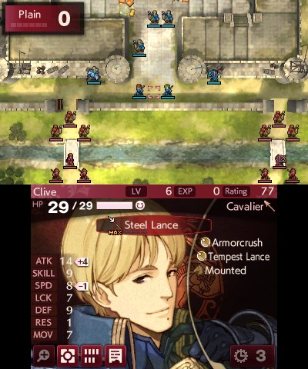

The Metro games have a difficulty setting that removes almost all of the UX aside from the in game watch this is a way to make the game harder but is also an interesting topic as this kind of difficulty shift is rarely used. This is also what occurs when the UX is not taken in to account when designing as the information you need is almost always visable in some way (you can count the rounds in most guns the universal charger shows batteries the watch shows filter time) but it is much harder to see and /or access.



Different genre also have different UX requirements this is why a game like Metro can get away with no/low UX but a strategey game has no freedom to do that without feeling unfair.

For our genre we do not need as much as much of a UX as enter the gungeon shows with a low denseity UI and this would be considered a rather complex top down shooter.

